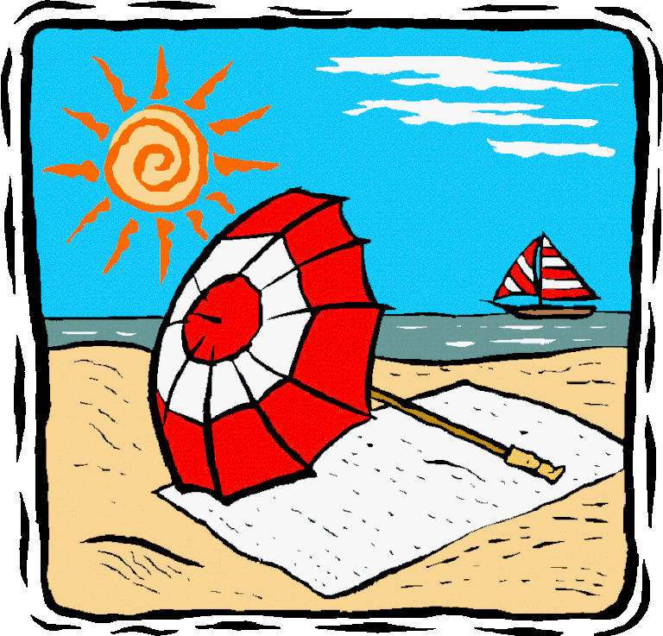Holiday Club Snacks

Week beginning 20th July 2026

Day/Date | Morning | Afternoon
Monday  20th | Toast/Pancakes/Crumpets/  Cereal | Yogurt & Fruit
Tuesday  21st | Toast/Pancakes/Crumpets/  Cereal | Rice Krispie Cakes & Watermelon
Wednesday  22nd | Toast/Pancakes/Crumpets/  Cereal | Cheese, Crackers & Apple
Thursday  23rd | Toast/Pancakes/Crumpets/  Cereal | Veg Sticks, Bread Sticks & Dip
Friday  24th | Toast/Pancakes/Crumpets/  Cereal | Fruit with Jelly & Ice cream

Holiday Club Snacks

Week beginning 27th July 2026

Day/Date | Morning | Afternoon
Monday  27th | Toast/Pancakes/  Crumpets/Cereal | Fruit Salad
Tuesday  28th | Toast/Pancakes/  Crumpets/Cereal | Cheese, Crackers  & Apple
Wednesday  29th | Toast/Pancakes/  Crumpets/Cereal | Own Decorated  Cookies
Thursday  30th | Toast/Pancakes/  Crumpets/Cereal | Sausage/Veg Roll & Baby Tomatoes
Friday  31st | Toast/Pancakes/  Crumpets/Cereal | Mini Rolls & Strawberries

Holiday Club Snacks

Week beginning 3rd August 2026

Day/Date | Morning | Afternoon
Monday  3rd | Toast/Pancakes/  Crumpets/Cereal | Fruit Kebabs
Tuesday  4th | Toast/Pancakes/  Crumpets/Cereal | Cheese, Crackers & Apple
Wednesday  5th | Toast/Pancakes/  Crumpets/Cereal | Homes made  Decorated Cakes
Thursday  6th | Toast/Pancakes/  Crumpets/Cereal | Jelly and Fruit
Friday  7th | Toast/Pancakes/  Crumpets/Cereal | Scone with Strawberries and Cream

Holiday Club Snacks

Week beginning 10th August 2026

Day/Date | Morning | Afternoon
Monday  10th | Toast/Pancakes/  Crumpets/Cereal | Cheese  and Crackers
Tuesday  11th | Toast/Pancakes/  Crumpets/Cereal | Flap Jacks
Wednesday  12th | Toast/Pancakes/  Crumpets/Cereal | Mini Rolls
Thursday  13th | Toast/Pancakes/  Crumpets/Cereal | Mini sausages, Veggie snacks & Tomatoes
Friday  14th | Toast/Pancakes/  Crumpets/Cereal | Fruit Salad & Ice Cream

Holiday Club Snacks

Week beginning 17th August 2026

Day/Date | Morning | Afternoon
Monday  17th | Toast/Pancakes/  Crumpets/Cereal | Fruit Cones
Tuesday  18th | Toast/Pancakes/  Crumpets/Cereal | Hotdogs
Wednesday  19th | Toast/Pancakes/  Crumpets/Cereal | Decorated  Biscuits
Thursday  20th | Toast/Pancakes/  Crumpets/Cereal | Cheese  Crackers & Apple
Friday  21st | Toast/Pancakes/  Crumpets/Cereal | Scones, Jam & Cream

Holiday Club Snacks

Week beginning 24th August 2026

Day/Date | Morning | Afternoon
Monday  24th | Toast/Pancakes/  Crumpets/Cereal | Fruit Kebabs
Tuesday  25th | Toast/Pancakes/  Crumpets/Cereal | Breadsticks & Dips
Wednesday  26th | Toast/Pancakes/  Crumpets/Cereal | Cup cakes
Thursday  27th | Toast/Pancakes/  Crumpets/Cereal | Cheese, Crackers & Apple
Friday  28th | Toast/Pancakes/  Crumpets/Cereal | Ice Cream Cornets & Fruit

