
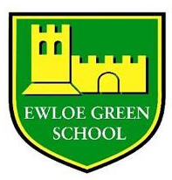
Action Plan for RotaKids
Action/ target | Success criteria | Resources | Timescale
1- Promote and sell as many Scribble and Giggle pads to raise as much money for Rotary and Ewloe Green Primary School as possible. | - Selling lots of pads!  - Using the share of the money raised for the school in a purposeful and needed way. | - Scribble and Giggle pads.  - Promotion material; for posters, website etc. | T1 & T2
2- Hold a “Wear Purple Day” to raise money for EndPolioNow. | - Children and staff come to school, wearing purple and bringing a donation. | - Presentation for in-class use. | HT1 - 24/10/25
3- Create and sell “Purple Pinky Pencils”. | - Quality product made.  - Profit made.  - Any money raised split, half to EndPolioNow, half to school. | - Pencils.  - PVA.  - Glitter.  - Promotion material; for posters, website etc. | T2 & T3
4- Taking part in Rotary’s artwork project with TfW. | - RotaKids leading whole-school project to produce artwork to be displayed at Hawarden railway station. | - Art resources. | Whole academic year

Proposed on: 30/09/25 Approved by:……………………….. Date:………………..

