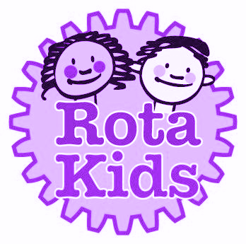
Rota Kids
Manifesto
2025-2026
Main Pledges
- Raise crucial funds for Rotary’s “End Polio” campaign.
- Raise the profile of Rotary International throughout the school.
- Promote Rotary’s mission through community projects.

