How to guide for google classroom.
There are two different way for you or your child to access google classroom.
- The App
- To use, download google classroom through the app store.
- Once you have downloaded put you child’s login details into the classroom (don’t worry that this is not a google account)
- once you have done this it will ask you if you are a student or teacher? Please click student.
- Finally, it will ask you to join your class and our code is seen as below.
Code: TO BE GENERATED (case sensitive)

- Hwb
- To go through a browser please type the following into your URL: https://hwb.gov.wales/
- Once you have done this please go to the top right-hand corner where you should see login, please click it and use your child’s log in to sign in.
- This should bring up your options page which looks like the picture below.
- Can you click on google for education which circled below.
- Finally, this should take you our google class page where you can type in the code
Code: TO BE GENERATED (case sensitive)
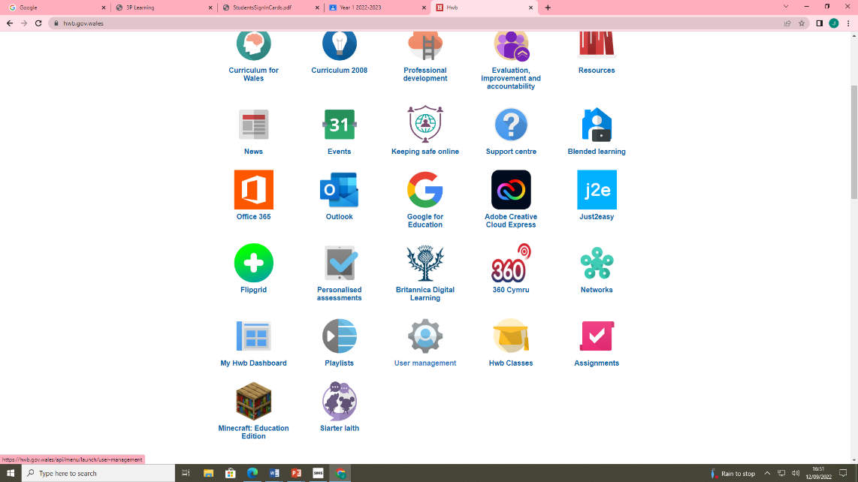

Either of these methods will get you onto google classroom if they do not please let your teacher know. For using google classroom please see the following page.
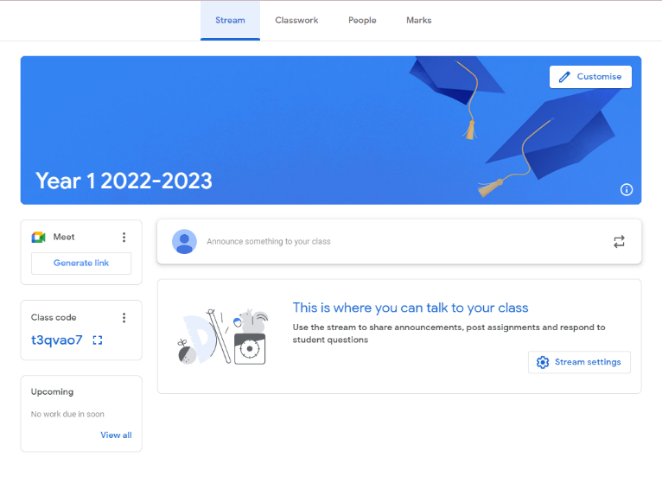
How to upload work on google classroom.
When you click on to a class page you will be greeted with the below picture. This is our class stream and all homework messages and information for the class will be posted here by your teachers.

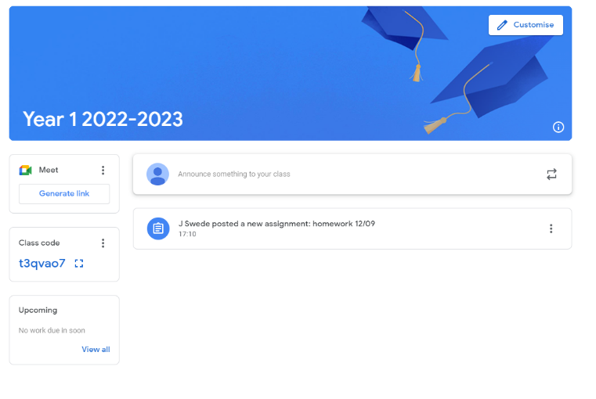
If you would like to access the class homework simply click on the assignment and it will open with a description of the work and any attachments that might be needed.

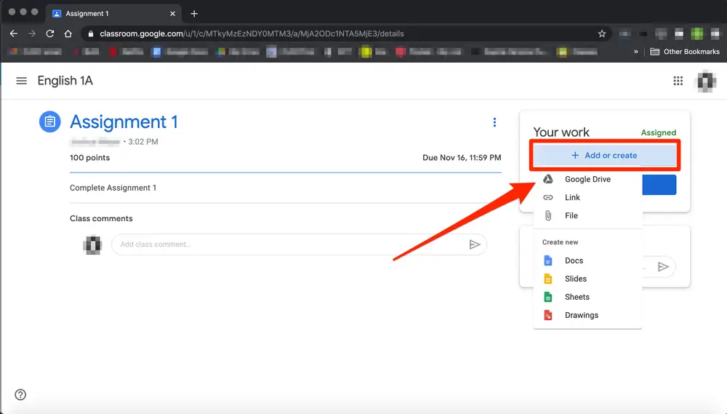

Once you have completed the homework, you should see a control panel to the right. This is where you can upload the piece of work. The best way we suggest is through a picture.
Once you have selected the item you would like to upload, simply click the blue button to turn it in.

